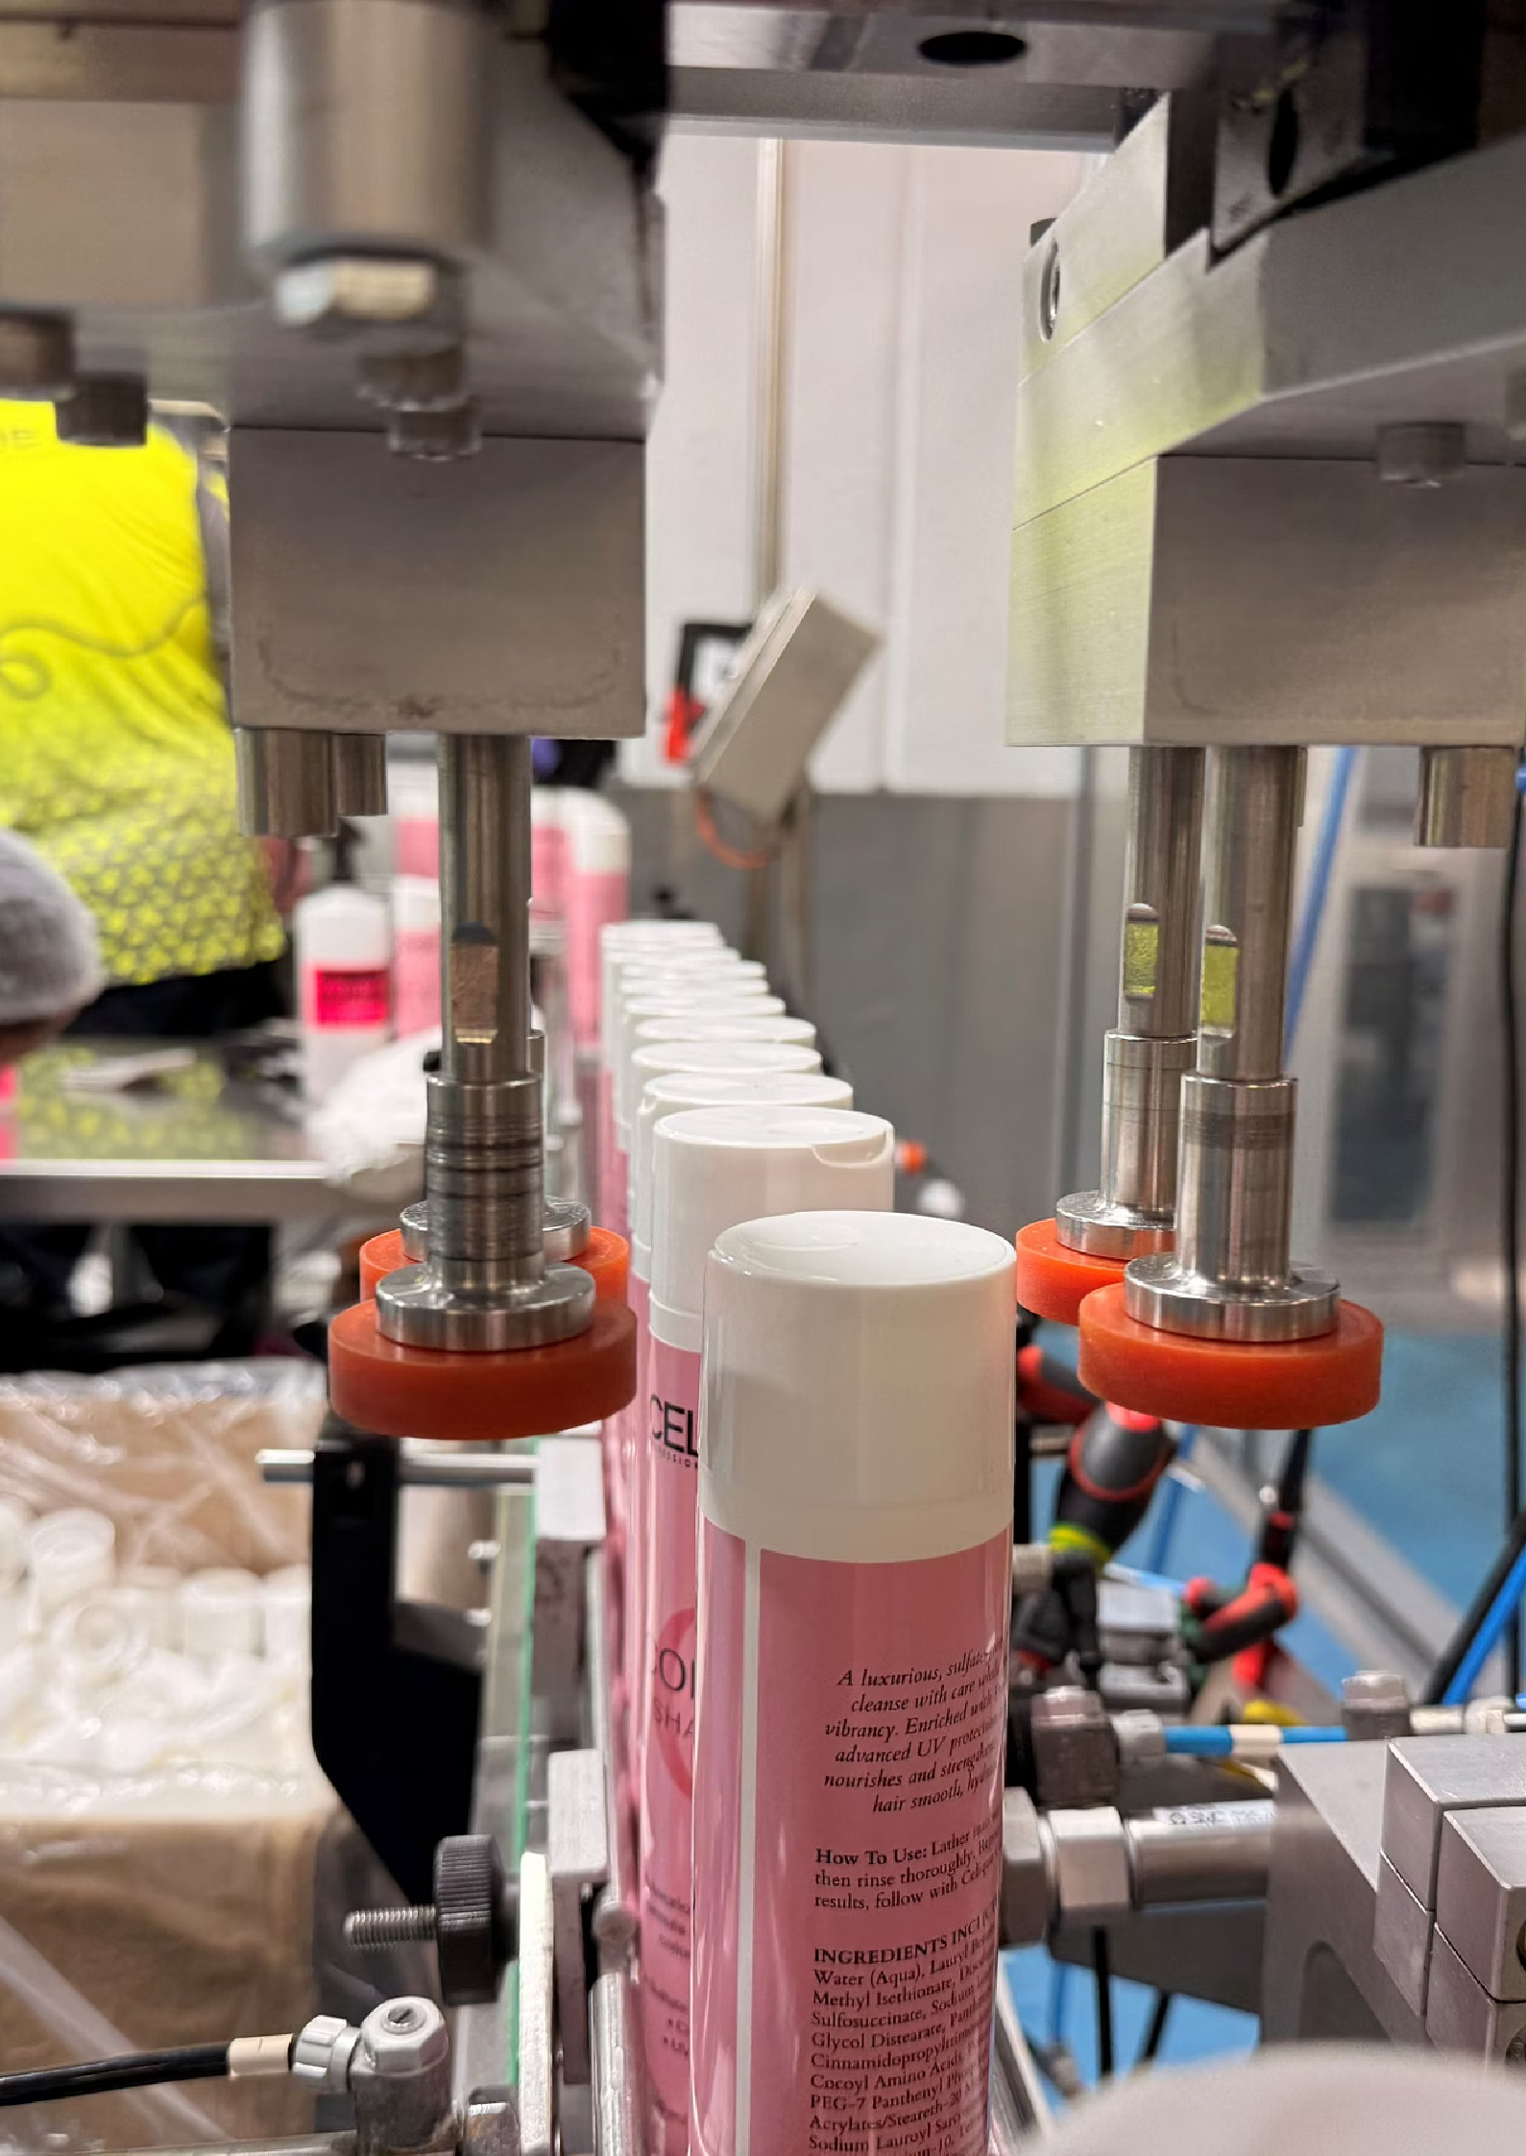


Automation Power Session

Assessment Report

Inline Pty Ltd
(NAME OF PLACE)

Site Visit: 16 January 2026

Report Date: 27 January 2026

Prepared by (NAME OF PERSON DOING IT)

CONFIDENTIAL

This document contains confidential information and is intended for internal use only. The recommendations provided are advisory in nature and should be validated with appropriate technical and commercial due diligence before implementation.


Property of UiLab Commercial in confidence

Document Overview






Introduction
  - What makes us different
  - Our goal for Inline
  - Summary of our site visit

General Observations

- Automation Opportunities
  - Rating System
  - Complexity, Timeline and Cost
  - Timeline and cost estimate

Automation Opportunities in Detail
  - Material Mixing Sequence
  - Production Line Sequence
  - General Automation Opportunities

The Automation Journey including next steps
  - The very next Step

Proposal for signature



2

Property of UiLab Commercial in confidence

Introduction
On 16 January 2026, UiLab visited (PLACE), organised and led by Sandra Kracke with maintenance and production staff joining on occasion.
UiLab visited the sites at (PLACE), which focus on liquid cosmetics with 1,300 different ingredients in stock. Tonka is designated to be the flagship production site and site for trials and tests for new developments.
Inline produces a wide range of products from sport drinks and powder mixtures to cosmetics in a "made to order" system. The company has achieved significant growth over recent years, with an impressive growth in the last five years.
Inline sees the requirement of large scale automation and robotics to achieve long term business goals.

Specifically:

Securing consistent quality across all lines

1

Increasing throughput and machine occupancy

2

Reduction in unplanned downtime

3

Increase to topline revenue and increase EBIT as percentage of turnover

4

Reduction in reliance on labour hire services

5

3

Property of UiLab Commercial in confidence

About UiLab



About UiLab
UiLab is a Logan City Council-owned, privately operated enterprise focused on driving growth and prosperity for Logan's industries and residents through the adoption of emerging technologies.
We specialise in AI and robotics, particularly automation within manufacturing and warehousing, to help businesses grow.
Our approach is pragmatic and customer focused. We combine in-depth automation consulting with next-generation skills training delivered to the local community.

What makes us different
Our goal is to create a thriving City of Logan that embraces and is embraced by the advanced and emerging technologies shaping the world around us.
If you thrive Logan thrives. Your success and growth is our focus.

Our goal for (PLACE)
We want to help Inline unlock production capacity, streamline core processes, and enable short, medium, and long-term business growth whilst lifting profitability. The success of Inline supports the success of the city, and we're excited to be on this journey with you.

We support your every step
We offer full service, stage by stage support for each project.

Scope definition &
process analysis
Procurement, design validation & factory acceptance
Ongoing support &
growth

1
2
3
4
5

Feasibility, vendor selection and project plan
Delivery, commissioning & handover

More detail on each stage on page16

4

Property of UiLab Commercial in confidence

General Observations
The following observations may help identify additional automation potential:
Fault vs. Cost Analysis
If the process engineer reviews the production process with "stage in which fault is noticed vs cost of fixing" in mind, this might uncover additional automation potential.
Handling Frequency
Another thought that can uncover automation potential is asking how many times each part is being picked up by the same person.
Excel Sheets and Handwritten Labels
Experience shows that every Excel sheet is an automation that hasn't happened yet or a bypass where automation (like ERP) has failed.
Downtime Due to Spillage
If we could receive a list of what caused downtime in what extent and what frequency, we could investigate with better focus if desired.
Upcoming KPI
System
An upcoming KPI system has been mentioned and we would be happy to contribute our experience to the project. Not so much to the KPI itself, but more how data fed into it could be fed automatically.

Automation Opportunities

Rating System
The following rating system has been used throughout this report to provide quick-reference assessments:

Rating | Complexity | Timeline | Pricing
1/3 | Off the shelf solution | Under 4 months | Under $50,000
2/3 | Requires research; integrator consultation | 4 to 12 months | Under $300,000
3/3 | New frontiers; tailored solutions; 3+  months development | 12+ months | Over $300,000 (individual assessment)

5

Property of UiLab Commercial in confidence

Complexity, Timeline and Cost table
The following table summarises all identified automation opportunities with their assessed complexity, timeline, and pricing ratings.

Section | Automation Opportunity | Complexity | Timeline | Pricing | Page
Material Mixing | Dispensing/Weighing 3 Stage  2 (Automated Dispensers) | 1/3 | 1/3 | 2/3 | 8
Material Mixing | Dispensing/Weighing 3 Stage  3 (ERP/AI Planning) | 2/3 | 2/3 | 2/3 | 9
Material Mixing | Dispensing/Weighing 3 Stage  4 (Full AutomatioN) | 3/3 | 3/3 | 2/3 | 9
Material Mixing | Loading into Mixing Chamber | 2/3 | 1/3 | 2/3 | 9
Material Mixing | Testing & Re-calibration  (Delivery Robot) | 1/3 | 1/3 | 1/3 | 10
Material Mixing | Cleaning of Mixing Chamber  (Standard) | 1/3 | 2/3 | 2/3 | 10
Material Mixing | Cleaning of Mixing Chamber  (Fixed Mixer) | 2/3 | 2/3 | 2/3 | 10
Production Line | Bottle Positioning System  (Cobot) | 2/3 | 1/3 | 1/3 | 11
Production Line | Cap Application (Cobot) | 2/3 | 1/3 | 1/3 | 11
Production Line | Cap Verification (Optics) | 1/3 | 1/3 | 1/3 | 12
Production Line | Bottle Weighing | 2/3 | 1/3 | 1/3 | 12
Production Line | Checking and Packing (Cobot) | 2/3 | 1/3 | 1/3 | 13
General | Logistics 3 AMR Systems | 3/3 | 2/3 | 2/3 3 3/3 | 14
General | Logistics 3 Trolley/Identifier System | 3/3 | 1/3 | 1/3 | 14
General | Planning/Urgencies (AI Model) | 2/3 | 1/3 | 1/3 | 15
General | Cleaning Robot (Autonomous) | 1/3 | 1/3 | 1/3 | 15

6

Property of UiLab Commercial in confidence

Timeline and cost estimate
Whilst each step is itemised, we can work on multiple steps concurrently. As a general guide we estimate a working relationship of two to three years however this could extend as business needs grow and evolve.

Note: These numbers are indicative and will become firmer as we progress with a full scope

Section | Production Line | Material Mixing | Warehousing/General
Estimated time | Month 1 - Month 8 | Month 9 - Month 18 | Month 19 - Month 26
Estimated cost | $200,000 - $300,000 | $800,000 - $1.2M | $500,000 - $1M
UiLab Support | Per project fixed fee  or  Retainer based  agreement | Per project fixed fee  or  Retainer based  agreement | Per project fixed fee  or  Retainer based  agreement

7

Property of UiLab Commercial in confidence

Automation Opportunities
in detail

Material Mixing Sequence
The following section outlines the material mixing process as observed during the site visit, with automation recommendations for each step. Note: This is not necessarily the order we would advise for implementation.

Recipe Request
The recipe request is sent to the warehouse, which then moves out and collects all ingredients. Currently done via mail or other work order documents.
Recommendation: For future automation, consider automating this through an ERP system that combines all later automation steps.

Dispensing/Weighing Material
This process could be automated to increase efficiency, remove human error and fulfil documentation requirements.

Stage 1: Foundation

List all ingredients, identify top 10%/20%/50% (internal). Assign storage locations to every ingredient.

Stage 2.1: Automated Dispensers

Refill to automated dispensers with permanent locations, connected to SCADA system. This will also allow minimum inventory management and stocktake, as well as weigh and document dispense and record actions.

Complexity | Timeline | Pricing
1/3 | 1/3 | 2/3

Stage 2.2: Expansion

Add more dispensers subsequently as the system proves effective.

8

Property of UiLab Commercial in confidence

Material Mixing Sequence (continued)

Stage 3: ERP/AI Planning Integration

Hand over to ERP/AI Planning to create a dispensing system: A recipe gets published on a handheld, telling each person where to go, scanning the dispenser with the dispenser only giving material if all ingredients and parts are available to run this order, then sending to the next location.

Complexity | Timeline | Pricing
2/3 | 2/3 | 2/3

Stage 4: Full Automation

Consider a fully automated dispensing system, including feeding to the mixers, cleaning and surveillance. This would only work in a new build factory as retrofitting would likely have a very high ROI.

Complexity | Timeline | Pricing
3/3 | 3/3 | 2/3

Loading into Mixing Chamber
Currently ingredients are loaded with a step/ladder system or a cage/forklift system. A crane with a specifically designed loading platform would remove the heavy lifting requirement.
An automated loading system could convey directly to the tank with a mixing chamber on the ground with a flexible hose system and a cleaning cycle. This could be located next to the ingredients to remove the logistics steps. As there is plenty of room towards the roof, a fixed piping system along the higher structures with a flexible end part could be considered.

Note: This automation would increase water usage as it would need a cleaning cycle after every use, although it might be worth it as it eliminates two steps in the process and further human error.

Complexity | Timeline | Pricing
2/3 | 1/3 | 2/3

9

Property of UiLab Commercial in confidence

Material Mixing Sequence (continued)

Testing and Re-calibration
Testing (and follow up actions) is a complex topic that may need to be looked at individually. Currently, samples are delivered by hand.
Ambassador Project Opportunity: We see this as an excellent opportunity to have sample delivery outsourced to a delivery robot (non-flying drone) to raise awareness for cobots within the production and have a quick reference project with limited costs to gain experience with handling and operating robots.
This wouldn't follow a strict ROI approach; rather, it would serve as an ambassador project. Delivery robots range from Pudu to Boston Dynamics and Starship-style robots (our favourite) could be used as a trial to send objects throughout the factory.

Complexity | Timeline | Pricing
1/3 | 1/3 | 1/3

Cleaning of Mixing Chamber
This could be automated by having a designated cleaning position and a high pressure washing probe from the top, recognising the tank that needs cleaning via RFID/QR, then having the tailored cleaning cycle executed.
Algorithms can calculate coverage on the inner areas with focus on heavily polluted areas. Cleaning could be verified with an optic system.

Complexity | Timeline | Pricing
1/3 | 2/3 | 2/3

Note: This may initially not work with tanks that have a fixed mixer on the inside. Those need to be individually programmed to ensure 100% coverage.

Complexity | Timeline | Pricing
2/3 | 2/3 | 2/3

10

Property of UiLab Commercial in confidence

Production Line Sequence

Bottle Positioning System
Currently bottles are unloaded from a box by a person onto a table that rotates and feeds the bottles to the line.
Some bottles tip over and need correction.

Recommendation: Remove the table entirely and have a designated box area in which the carton is placed. Use a cobot (UR) to pick any shaped bottle from the box and directly put on the line in the correct orientation. A cobot moves slower (still fast enough) and needs no additional safety or fencing so could work around humans.

Complexity | Timeline | Pricing
2/3 | 1/3 | 1/3

Alternatively, this could be done by a robot, fencing off a small area in which a robot works with an optical system to unload the boxes. This is more expensive and complex and only needed if we are talking about higher speeds (60 units per minute and more).

Cap Application
Currently the cap is taken out of the box by a human and then put on by a human.

Recommendation: Identical to the bottle, this could be automated with a cobot that takes the cap and puts it on the bottle.

Complexity | Timeline | Pricing
2/3 | 1/3 | 1/3

This might not work with all caps in the beginning as more complex caps might require a more complex gripping system, but could be extended gradually. If much higher speeds are required, a FANUC Delta robot system could be considered, although this might struggle with the variety of parts.

11

Property of UiLab Commercial in confidence

Production Line Sequence (continued)

Cap Verification
An unsecured or wrongly tightened cap might lead to spillage that will cause downtime.

Recommendation: Install two optic systems that use a comparison mechanism to verify the cap is on properly. This could also include a bypass solution that removes all bottles from the line that need checking and verification. This checkpoint could be included at any point in the sequence.

In the beginning this would need a teach system (needs to be shown what it should look like once) and with an implemented ERP and SCADA system this could run autonomously. We consider this step very important once the entire line runs fully automatic.

Complexity | Timeline | Pricing
1/3 | 1/3 | 1/3

Bottle Weighing
Weighing bottles at certain points in the process may be required.

Recommendation: A lifting mechanism that lifts up the bottle for 1 second / 3mm and compares the actual and required weight. If in range it will drop it back to the line, if not it would remove it from the line. This could either be an individual cobot at any place (on wheels to be exchanged between production lines) or a device attached on the other side of the cap tightening mechanism.

Complexity | Timeline | Pricing
2/3 | 1/3 | 1/3

12

Property of UiLab Commercial in confidence

Production Line Sequence (continued)

Checking and Packing
Checking bottles is a topic we may need to look at individually once criteria are defined.

Recommendation: Similar to loading bottles onto the table, this step could be reversed: A cobot picks up the finished bottle, packs it and puts the sealed box on a pallet. This would merge three steps into one cobot. The footprint wouldn't change as this would remove the turning table.

Complexity | Timeline | Pricing
2/3 | 1/3 | 1/3

Additional Note: It might be worth standardising boxes to as few varieties as possible as this would make all future steps easier. Currently boxes are unfolded by hand which could be done by previous cobots once standardised. An intermediate solution would be a feeder system.

Implementation Recommendation
We recommend minimising risk and impact on production by changing one of the lines to an automation line and running non-urgent products on it to familiarise with the system. Then it could be extended more and more according to experience and comfort.

13

Property of UiLab Commercial in confidence

General Automation Opportunities

Logistics
Currently there are 5-6 forklifts (Horizon) in operation with high workload. Logistics is currently 100% manual.

The nature of the production would make AMR (Autonomous Mobile Robot) systems very beneficial to trial and then extend subsequently. Unfortunately, no logistics system would work without designated areas.

Implementation Approach
1
2

Stage 1
Physical designated areas

Stage 2
Virtual designation in ERP

Once these have been started, intra-company pallets could be sent via AMRs, reducing costs, emissions and increasing frequencies.

Complexity | Timeline | Pricing
3/3 | 2/3 | 2/3 3 3/3

* Preparation for AMR Systems

Consider a standardised attachment for internal logistics pallets or a trolley/pallet system that could carry an identifier (QR/RFID) as a preparation for AMR systems and to trace order progress throughout production if the positioning is mirrored back to the ERP.
This could also reduce human error and make sure orders are only started if all parts are available ("on the trolley").

Complexity | Timeline | Pricing
3/3 | 1/3 | 1/3

Assessment: We see a lot of potential in automating logistics as this seems to be a naturally grown area that could benefit from trimming and systemisation.

14

Property of UiLab Commercial in confidence

General Automation Opportunities (continued)

Planning/Urgencies
With or without an ERP system, if machine data and variables are collected and put into an algorithm, UiLab could create an AI-model that could assist with optimising machine occupancy and workload and support planning predictions (similar to nesting software for sheet metal orientation).

In a second step this would support urgency management and tracing of orders within production.

Complexity | Timeline | Pricing
2/3 | 1/3 | 1/3

Cleaning Robot (Autonomous)
Research and personal experience show that people keep a place tidier if they know there is a robot driving around cleaning up the floor (as they don't want to obstruct and block it).
Benefits: A cleaning robot could prepare robot awareness and encourage people to maintain a tidier workplace.

Complexity | Timeline | Pricing
1/3 | 1/3 | 1/3

Heating/Cooling Acceleration
Accelerating heating/cooling cycles has been mentioned. Despite this not being automation in a classical way, UiLab could support and look into this from an engineering perspective if this is a topic worth investigating.

15

Property of UiLab Commercial in confidence

The Automation Journey

The full journey at a glance

Stage | Focus | Status
Stage 1.1 | Scope definition & process analysis | 7 Complete
Stage 1.2 | Feasibility, vendor selection &  project plan | Next
Stage 2 | Procurement, design validation  & factory acceptance | Future
Stage 3 | Delivery, commissioning &  handover | Future
Stage 4 | Ongoing support & growth | Future

Stage 1.2: The very next Step

Project Scoping & Vendor Selection
Building on the initial scope definition and process analysis completed in Stage 1.1, this stage delivers the detailed planning and vendor engagement required to move confidently into implementation.

What we deliver:

- Feasibility studies 3 Technical research and initial timeline analysis to confirm what's achievable
- Integrator engagement 3 Independent assessment of vendor capabilities, separating sales claims from realistic project scope
- Process sequencing 3 Detailed documentation of the automation workflow
- Internal requirements analysis 3 Identifying infrastructure required within the facility to deliver the project
(utilities, infrastructure, resources)
- Procurement support 3 Drafting inquiries, reviewing quotes, and ensuring like-for-like comparison across vendors
- Management summary 3 Clear recommendation with final quote for decision-making

16

Property of UiLab Commercial in confidence

Outcome:
A comprehensive project plan with validated costings, realistic timelines, and a recommended pathway giving
you the confidence to proceed to Stage 2 (Making it happen).

Note: As a conversation starter, we suggest discussing the following potential sequence of work



Section 1:
Production Line
- Focus area: We go deep on your production line to increase capacity to meet growth goals. We increase uptime and reduce reliance on labour hire.
- Deliverable: Automated production lines with lower staffing requirements and increased output capacity aligned to your growth needs.

Section 2:

Material Mixing
- Focus area: Invest in material mixing to unlock further growth through faster, more accurate processing.
- Deliverable: An automated mixing process that is faster, more accurate, more efficient, and safer by removing the human-error factor.

Section 3: Warehousing Optimisation

- Focus area: We take a deep look at your warehousing layout, focused on creating a safer, automated environment that enables upstream and downstream processes to flow more seamlessly with less error and risk.
- Deliverable: An automated warehousing facility that supports both mixing and production line activity.

17


Property of UiLab Commercial in confidence

Proposal

Stage 1.2: Project Scoping & Vendor Selection

Prepared for:
Prepared by: UiLab (Underwood Innovation Lab Pty Ltd)
Date: 26 January 2026
Start Date: 1 March 2026

Scope of Work

- Feasibility studies Technical research and initial timeline analysis to confirm what's achievable
- Integrator engagement Independent assessment of vendor capabilities, separating sales claims from realistic project scope
- Process sequencing Detailed documentation of the automation workflow
- Internal requirements analysis Identifying infrastructure required within the facility to deliver the project
- Procurement support Drafting inquiries, reviewing quotes, and ensuring like-for-like comparison across vendors
- Management summary Clear recommendation with final quote for decision-making

Investment & Timeline
Investment
$27,300 + GST
Timeline
6 weeks

Acceptance
By signing below, both parties agree to the scope of work, investment, and timeline outlined in this proposal.
For Inline Pty Ltd
Signature:
Name:
Date:
Underwood Innovation Lab Pty Ltd
Signature:
Name:
Date:


18

We are looking forward to working with you and bringing automation to life!



From Logan with love Underwood Innovation Lab (UiLab)
Contact Us:

Email:

Phone:

Website: www.uilab.com.au

Address: Unit 14/1 Belvedere Drive, Park Ridge QLD 4125

